

Curriculum Overview

This document aims to provide an overview of policy to support the implementation of Area specific Subject policies.

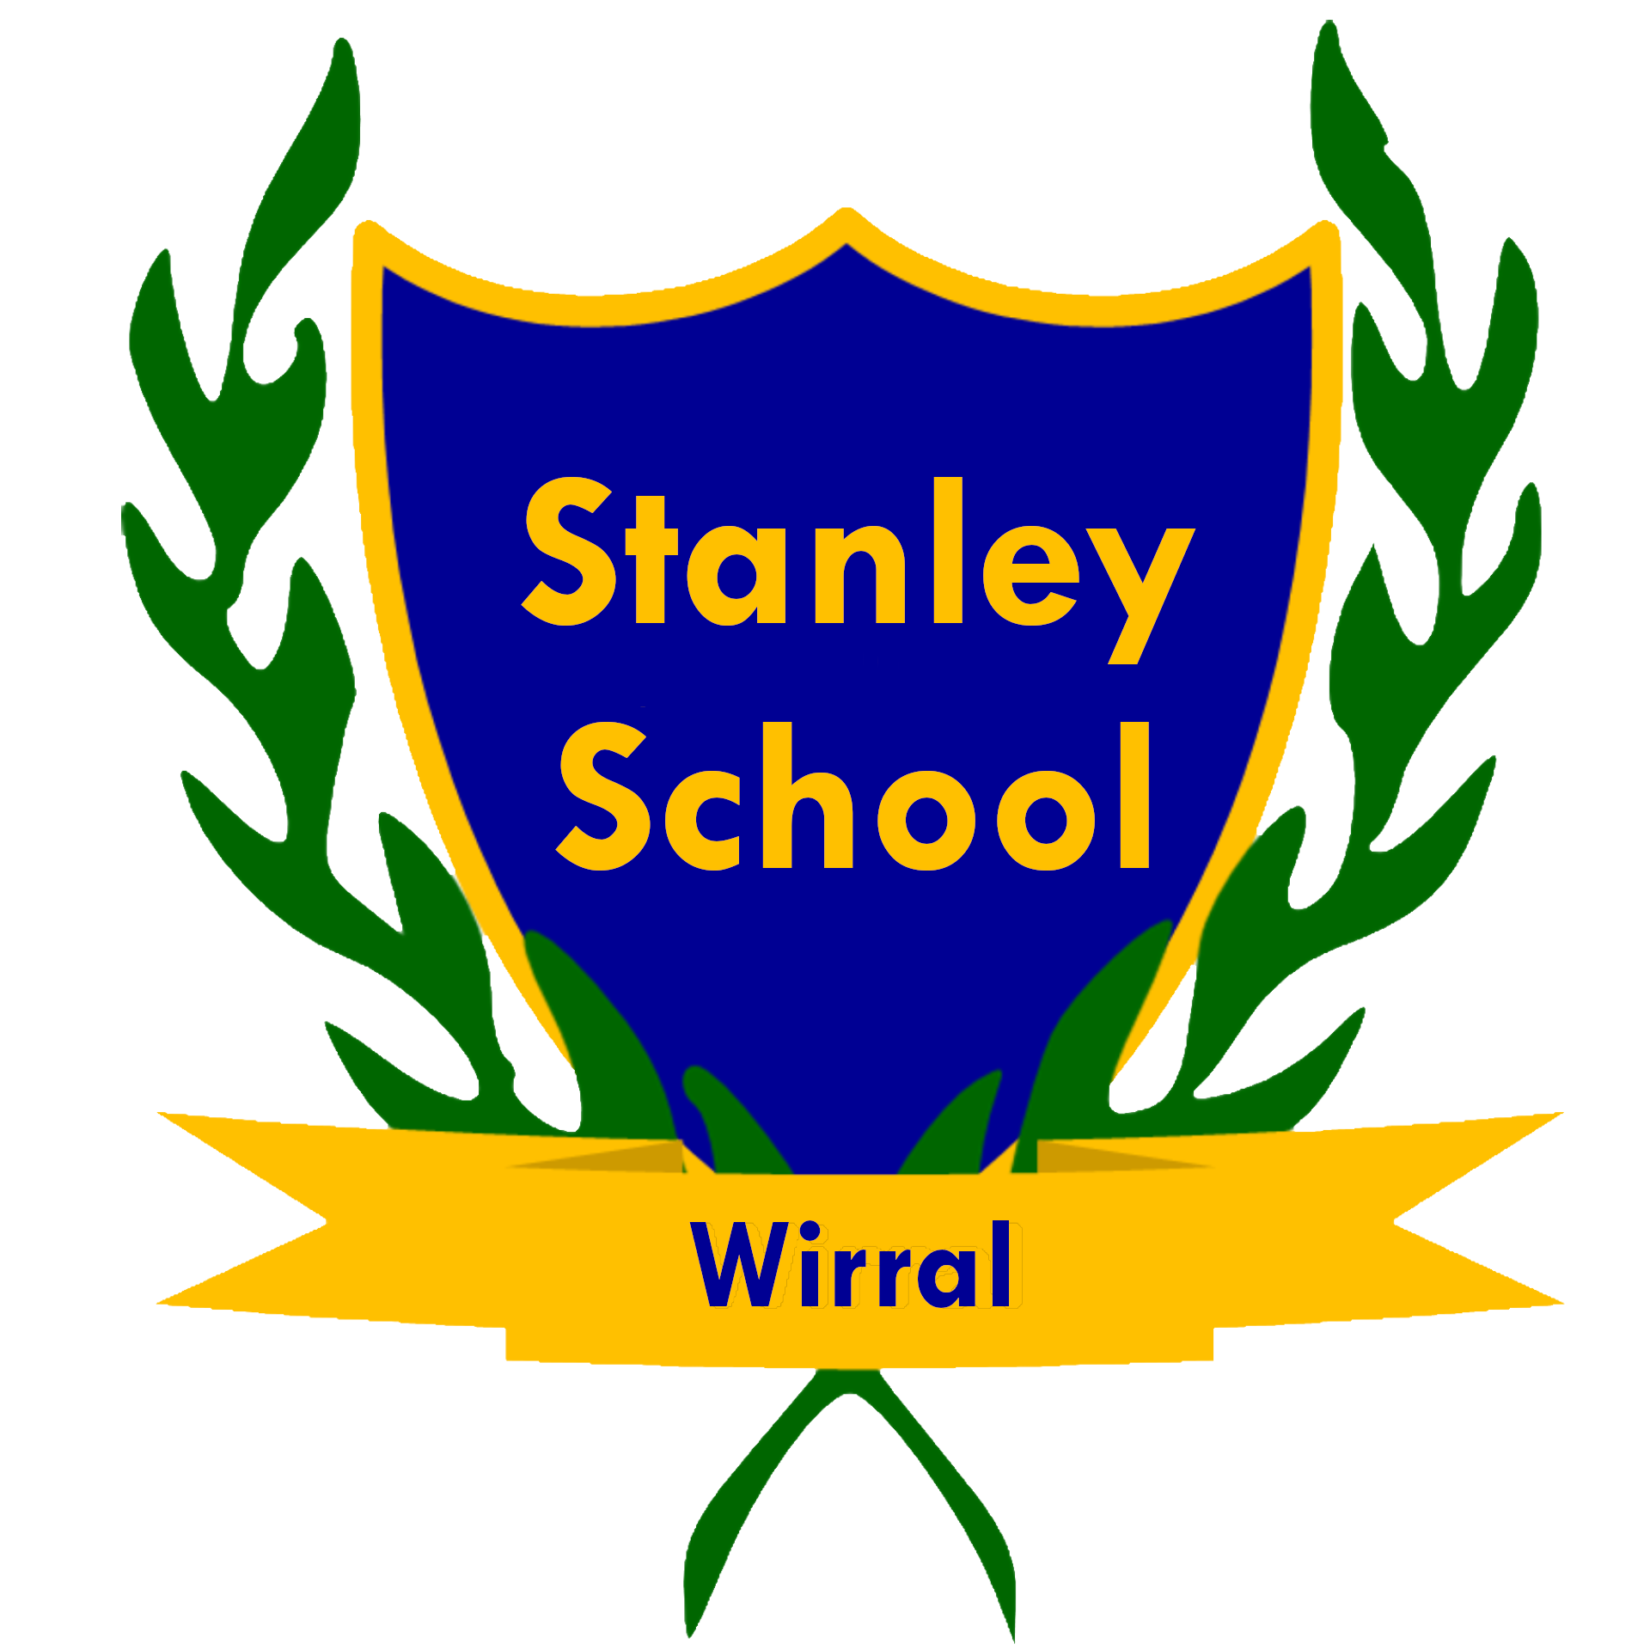

Contents
1. Introduction 3
2. Curriculum Intent 3
3. Our Pathways 3
Purple Pathway – Pre-Formal 4
Indigo Pathway – Informal 4
Saffron Pathway – Semi-Formal 5
Fuchsia Pathway – Formal 5
4. Preparation for Adulthood (PfA) 5
5. Implementation 6
6. Impact and Evaluation 7
7. Conclusion 7
8. Policy Review 8

1. Introduction
At Stanley School, we deliver a rich, inclusive and meaningful curriculum that is rooted in our core values of Caring, Learning, Inclusive, and Ambitious. Every child at Stanley is valued for who they are and supported to achieve their full potential. We recognise the uniqueness of each pupil and commit to delivering a curriculum that is engaging, aspirational, and personalised to meet individual developmental, emotional and academic needs.
Our curriculum is underpinned by the belief that all children can learn, achieve, and contribute, given the right support and opportunities. It is designed to be dynamic and adaptable, preparing learners not only for their next steps in education but also for meaningful and fulfilling lives in their communities and the wider world.
Our guiding principles promote the development of essential life skills, communication, problem-solving, and a sense of belonging, encouraging each pupil to grow as a confident and independent learner within a safe, supportive environment.

2. Curriculum Intent
Our curriculum is designed to:
- Provide a broad, balanced, and personalised learning experience for all pupils.
- Reflect our commitment to celebrating diversity and promoting inclusion.
- Prepare children for adulthood through the development of independence, communication, emotional regulation, and social understanding.
- Embed life skills, British values, and cultural capital across every phase.
- Offer flexible learning that is appropriate to the needs of each child through four distinct but interrelated pathways.
- Recognise the importance of holistic development including physical, emotional, cognitive, and sensory learning.
- Provide access to rich experiences beyond the classroom including community visits, outdoor learning, and multi-sensory engagement.

3. Our Pathways
We deliver our curriculum through four progressive pathways, ensuring every pupil accesses learning appropriate to their developmental stage and individual learning style. These pathways are dynamic and allow for movement between them depending on pupil development and need.

Purple Pathway – Pre-Formal
For learners with profound and multiple learning difficulties (PMLD). The focus is on:
- Early communication, interaction, and cognition.
- Sensory engagement and physical development.
- Developing consistency in responses and environmental awareness.
- Establishing trust and predictable routines.
The curriculum is highly individualised and includes therapies such as physiotherapy, rebound therapy, massage stories and intensive interaction. Communication is developed through non-verbal methods including eye gaze, body language, and switches. Pupils may work on early anticipation, cause and effect, and consistency of response.
Preparation for adulthood begins with early life skills, such as developing choice-making, self-expression through non-verbal means, and engagement in daily routines like eating, dressing, and toileting with increasing independence.

Indigo Pathway – Informal
For learners with complex needs, often including autism, who are “learning to be” rather than “learning to do”:
- Focuses on sensory regulation, communication, independence, and emotional wellbeing.
- Learning is experiential, often through motivating, real-life contexts.
- Encourages early problem solving and development of engagement.
- Supports learners through a flexible, non-linear curriculum that allows simultaneous achievement across multiple areas.
These pupils may be behavioural communicators and require a sensory-informed approach. The curriculum focuses on high levels of engagement, structured routines, and personalised activities to support interaction and regulation.
PfA outcomes are developed through learning basic functional tasks, managing personal care, and participating in routines with support. Communication development and learning through structured play help build foundations for later independence.

Saffron Pathway – Semi-Formal
For learners with severe learning difficulties who benefit from thematic, experiential learning:
- Develops early academic concepts in literacy and numeracy.
- Prioritises communication, social understanding, and independence.
- Uses real-life contexts and structured routines to embed knowledge.
- Incorporates the EYFS framework to support learning through seven developmental areas.
The curriculum includes creative and physical learning as well as personal and social development. It is play-based and allows for learning through repetition and meaningful contexts. Children are supported to develop self-help skills such as shopping, food preparation, dressing, and developing awareness of their own needs and surroundings.
Children learn through personalised experiences which support them in generalising and applying skills across contexts.

Fuchsia Pathway – Formal
For pupils ready to access modified National Curriculum content:
- Emphasises skills and knowledge acquisition alongside functional application.
- Combines subject-specific learning with real-world tasks.
- Focuses on literacy, numeracy, science, PSHE, and life skills.
- Incorporates both integrated and discrete approaches to learning.
Pupils are encouraged to reason, hypothesise, and engage in more abstract learning. They work towards National Curriculum end of year expectations for Key Stage 1, supported by adapted materials and accessible teaching strategies. Life skills such as budgeting, self-care, understanding relationships, and community safety are embedded throughout.
Preparation for adulthood includes structured learning in independence, responsibility, and transition planning.

4. Preparation for Adulthood (PfA)
We are committed to ensuring that Preparation for Adulthood (PfA) is woven into every phase of learning—starting from the earliest years, in line with the SEND Code of Practice (2015).
PfA encompasses four key outcome areas:
- Employment and further learning
- Independent living
- Community inclusion
- Health and wellbeing
Across all pathways, pupils engage with these outcomes in developmentally appropriate ways:
- Purple Pathway: making and communicating choices, tolerating personal care routines, and engaging with sensory environments.
- Indigo Pathway: following simple instructions, developing basic independence, learning about safety through structured play and routines.
- Saffron Pathway: taking part in group routines, role-playing community-based tasks, handling real money, and building awareness of feelings and relationships.
- Fuchsia Pathway: developing budgeting skills, road safety, using public transport with support, understanding employment roles, and engaging in structured life skills programmes.
In all pathways, we promote:
- Self-care: from eating and toileting to understanding hygiene and dressing.
- Independence: from supported routines to fully planned self-managed tasks.
- Decision-making and self-advocacy: at all levels, through choices, communication systems, and structured discussion.

5. Implementation
- Learning is planned to be meaningful, engaging, and linked to real-life contexts.
- Teaching is adapted using a range of specialist, evidence-based strategies tailored to the individual needs of pupils with ASC and complex needs. These incorporate sensory integration techniques, a total communication approach, visual supports, personalised timetables, reduced language processing demands, intensive interaction, attention autism and a low-arousal environment to support engagement and regulation.
- Experiences are personalised and recorded using both formal software (see below) and Experience Passports to celebrate holistic learning.
- We use thematic approaches to allow flexible but cohesive learning that adapts across abilities and interest areas.
- Curriculum delivery involves multi-disciplinary teams including therapists and external agencies, as appropriate.

6. Impact and Evaluation
We measure the success of our curriculum through:
- Progress in personalised learning outcomes using Evidence for Learning and PLG’s.
- Observed engagement, self-regulation, and independence in varied settings.
- Pupil voice, parental feedback, and collaborative review meetings.
- Contributions to the community, development of friendships, and emotional wellbeing.
- Monitoring of teaching and planning by curriculum leads to ensure consistency and high standards.

7. Conclusion
At Stanley School, our curriculum nurtures the whole child—supporting academic, social, emotional, and functional development. Grounded in our core values, and delivered through differentiated pathways, it empowers pupils to gain the skills and confidence they need to live safe, meaningful, and as-independent-as-possible lives.
We aspire for every child to thrive, and our curriculum ensures that each one is equipped with the tools they need to take their next steps in life—at school, at home, and in the wider world.

8. Policy Review
This document will be reviewed at least every three years, and sooner if required to reflect any significant changes to the curriculum within our school.

